Why the Game Industry has become very valuable and integrated with daily life and will continue to increase in value.

# Introduction:

The game Industry is very valuable globally in many ways and is growing and its economic value has been increasing exponentially and drastically over the past few years even producing more revenue that every other entertainment sector combined. Its even increasing in viewership such as streaming and E-sports audience even beating some streaming services, and Tv channels and as more strides are made in this sector it will continue to increase and be integrated in our daily lives.-

# The Value of the game Industry:

The value of the game Industry as been growing and has continued to surge and seems as though it will continue to do so exponentially, both globally and in the UK. The chart below shows the monetary value of the game industry from 2012 – 2023 (Statista, NewZoo 2020). The Global Video Gaming Industry is now estimated to be worth $159.3 Billion in 2020 currently and expected to finish at above $165, which is a sizeable increase of 9.3% from 2019 at $151 billion. The graph also estimates the video gaming industry to be worth $200 Billion by 2023. Asia Pacific is expected to be worth approximately $78 Billion in 2020 with China expected to contribute $40.9 Billion of consumer spending on gaming and the USA just under that with $36.9 Billion and the UK contributing £4 billion ($5.1 billion) and is expected to nearly triple to £10 billion ($12.8 billion) by 2023 ([**Robert Walters**](https://www.pocketgamer.biz/company/22180/robert-walters/) **2020)**.

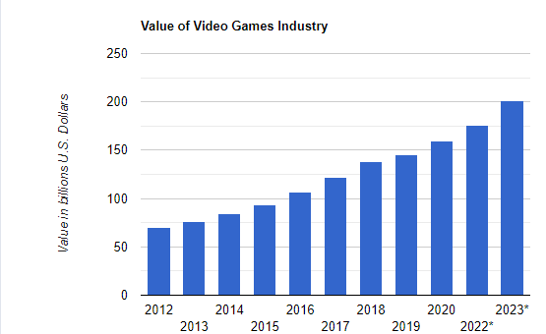

The game industry is worth more than double the entertainment industries such as books, movies, TV. In 2019, the global games market is estimated to generate $152.1 billion from 2.5 billion gamers around the world. By comparison, the global box office industry was worth $41.7 billion while global music revenues reached $19.1 billion in 2018. (Samuel Stewart 2019)

([Kayleigh Partleton](https://www.pocketgamer.biz/staff/100239/kayleigh-partleton/) 2019)

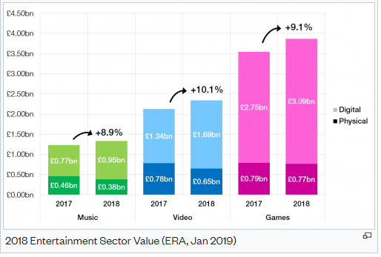

The graph above is the UK sector.

# The economic value:

## Jobs

The Games industry contributes £2.87bn to UK economy, supports nearly 50,000 jobs.

"Many might be surprised that the games industry contributed over 47,000 jobs, directly and indirectly, including over 16,000 in development and publishing roles, and the figures show that the creative ecosystem across our screen sectors is healthy and a critical part of the creative industries story in the UK - the fastest growing sector in the economy," quoted by CEO Dr Jo Twist

“The number of people directly employed by the Gaming industry in the UK (e.g. development, publishing, retail) was reported as 20,430 FTEs, and contributing £1.52 billion to the UK economy however when you include jobs that a result from the direct jobs ( jobs not linked to the production or sale of the game, such as media, PR, lawyers, office managers, cleaners and so on), the number is significantly higher

([**James Batchelor**](https://www.gamesindustry.biz/articles/?author=1570) **2018)**

Even though the lockdown caused by COVID-19 has severe effects on the workplace and certain industries, employment opportunities have grown 20 per cent year-on-year. However, the rise is significantly higher when looking at specific roles. For example, demand for game programmers has increased by 154 per cent, project management by 140 per cent and developers by 91 per cent as the demand has increased for games so to meet those needs more people need to be employed.

"In a sign of the increasing maturity of the UK sector, gaming companies are rapidly increasing recruitment into the sales and marketing space to better monetise their products. In fact, in 2019 there was a 25 per cent increase in marketing vacancies compared to the previous year." Meaning an increase in indirect jobs also.

Over the next five years, it is believed that there will be 80,000 positions within the UK's game industry, triple what it's at now.

## Streaming

Streaming can be live or pre recorded and streamers record themselves on many platform where they get money Not only do they get donation of any amount but they also get sponsorships and advertisement and they also tend to reupload clips from their live and gain money from that as well.

Also, by 2014, **Twitch** streams had more traffic than HBO's online service and people tend to watch them live or pre-recorded more and/or rather than T.V. In 2017 Twitch reports that it enjoys over 15 million daily active users who watch video streaming each day.

There are many streaming platforms such as Twitch, YouTube Gaming, Facebook,  [Microsoft](https://en.wikipedia.org/wiki/Microsoft)'s [Mixer](https://en.wikipedia.org/wiki/Mixer_(website)), which shut down in July 2020, [Smashcast.tv](https://en.wikipedia.org/wiki/Smashcast.tv), and many more.

# How it has become integrated with our daily life:

Gaming became more important in our daily life during the enforce lockdown as the number of gamers who say they are playing video games more now due to the COVID-19 pandemic increased between March 23 – June 3rd 2020 by 46% in the U.S., followed by 41% in France, 28% in the U.K. and 23% in Germany. Which has helpful as it contributed more to the industry, kept people inside and help them cope during that challenging periodWhere gaming really became integral was when it came to interaction, and during lockdown, “there was a substantial rise in new users looking to bridge the social limitation with friends and family by playing together online – this was particularly notable with the over 60's market who took to gaming to 'keep their brain in shape and play with grandchildren.”

**Nielsen, 2020**

For some it is more deeply integrated than others as it is either a career or taken very seriously by a large amount of the population. E.g. Japan’s market has more than 70 million gaming players

**Computer Entertainment Supplier’s Association, 2020**

As at August 2020 there are an estimated 3.1 billion people consuming video games, representing around 40% of the population of the planet.

**DFC Intelligence, 2020**

# Conclusion

So in summary the game industry has become very valuable over the years not only in monetary terms but also economically and as its still growing it will become even more valuable and this is due to how integrated it has become in our daily lives as we choose to watch it over mainstream T.V or watch others play it and this has been even more so since lockdown as more people had time to play, more people dad nothing else to do and others had more time to play it and it even brought people and families closer. Due to this year life changing event games have had an unexpected massive growth, impact, and importance. Increasing in audience, player and global and local revenue and even beat this year in the UK.

## Bibliography:

Sources: Statista, NewZoo: Video Game Industry Statistics in 2020 <https://www.wepc.com/news/video-game-statistics/>

[**Robert Walters**](https://www.pocketgamer.biz/company/22180/robert-walters/) **2020: The UK games market** https://www.pocketgamer.biz/news/74634/the-uk-games-market-worth-10-billion-in-2023/

# Samuel Stewart 2019 : Video game industry silently taking over entertainment world <https://www.ejinsight.com/eji/article/id/2280405/20191022-video-game-industry-silently-taking-over-entertainment-world>

# [Kayleigh Partleton](https://www.pocketgamer.biz/staff/100239/kayleigh-partleton/) 2019 : The UK games market could be worth £10 billion by 2023

<https://www.pocketgamer.biz/news/74634/the-uk-games-market-worth-10-billion-in-2023/>

[**James Batchelor**](https://www.gamesindustry.biz/articles/?author=1570) **2018 :** The Games industry contributes £2.87bn to UK economy, supports nearly 50,000 jobs

<https://www.gamesindustry.biz/articles/2018-10-09-games-industry-contributes-2-87bn-to-uk-economy-supports-nearly-50-000-jobs>

**Nielsen, Computer Entertainment Supplier’s Association, DFC Intelligence, 2020** :

https://www.wepc.com/news/video-game-statistics/

1035 words approximately

